Tracking, Staging, Commutting + Deploy to EC2
Olajide Kuti
Assignment 9:
Task 1 – Verify Git Setup and Enter the Repository
Screenshot 1
Screenshot 2
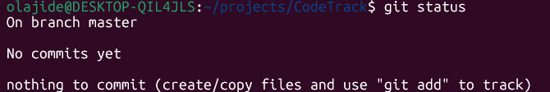

Task 2 – Create index.html and stlye.css
Screenshot 3
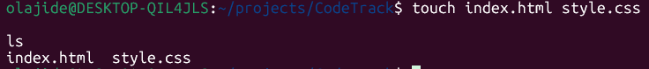

Task 3 – Add Starter Content
Screenshot 4
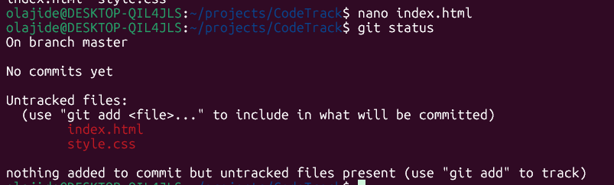

Task 4 – Track and Stage Files Correctly
Screenshot 5
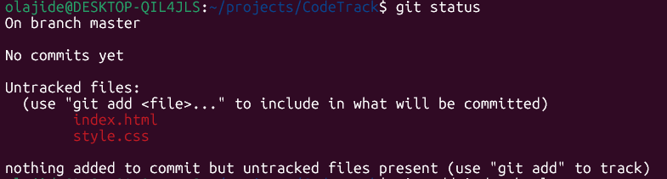
Screenshot 6
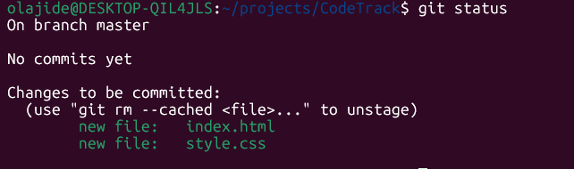

Task 5 – Create the First commit
Screenshot 7
Screenshot 8

Task 6 – Modify index.html and create a second commit
Screenshot 9
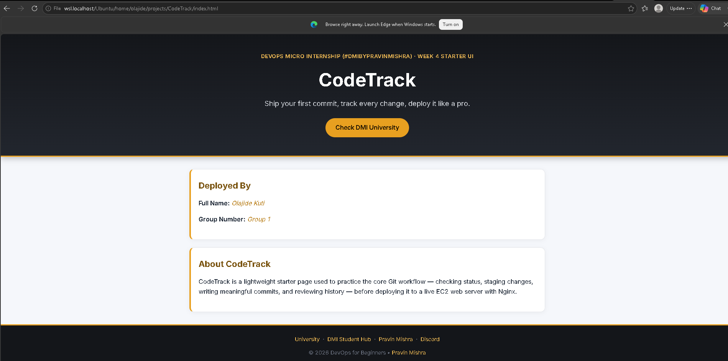
Screenshot 10
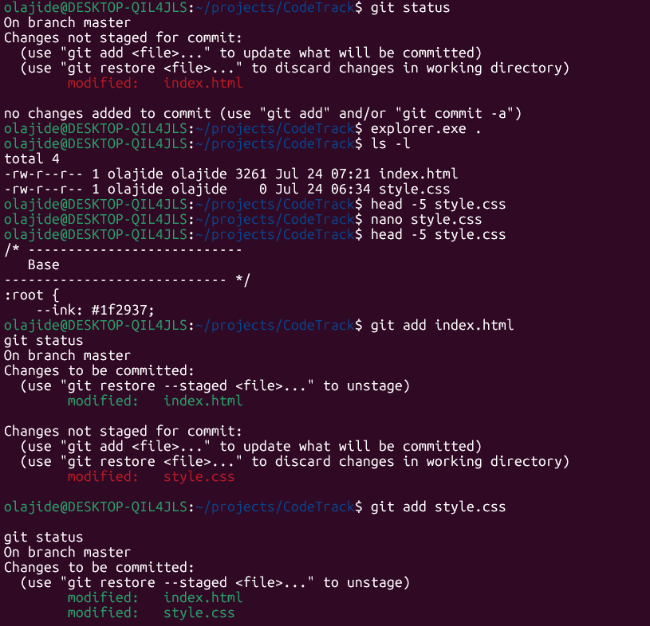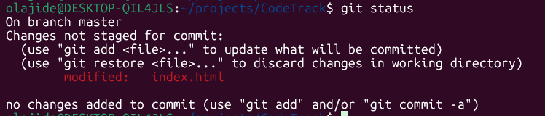
Screenshot 11

Screenshot 12
Task 7 – Deploy to EC2 with Nginx (Static Website)
Screenshot 13
Screenshot 14
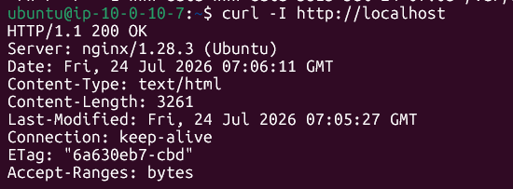
Screenshot 15
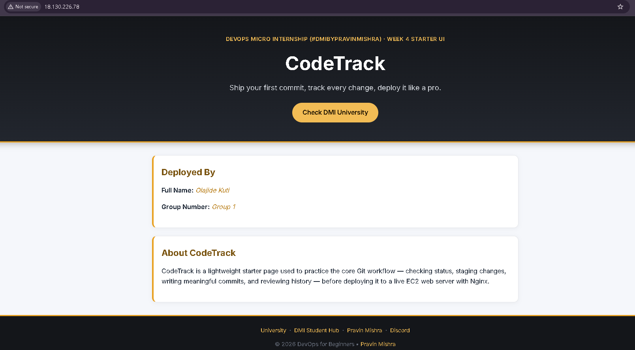
Built and deployed a static web application to AWS EC2 using Git and Nginx.
This week I practised:
- Creating a clean Git workflow with meaningful commits
- Tracking and staging changes with Git
- Reviewing commit history
- Deploying a static website to an Ubuntu EC2 instance
- Configuring and validating Nginx as the web server
- Troubleshooting SSH key permissions and deployment issues
Although this was part of a structured DevOps lab, the workflow closely mirrors the manual deployment process used before introducing CI/CD pipelines.

